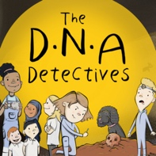
Podcast 5 DNA: Fighting Malaria

True or False
Here are the questions and answers from Podcast 5 DNA: Fighting Malaria.

 | Question | Answer
1. | A parasite is an organism that needs sugar to survive. | FALSE  A parasite is an organism that needs another organism to survive.
2. | A mosquito has 230 million As, Cs, Gs and Ts. A parasite has 23 million As, Cs, Gs and Ts. | TRUE
3. | It is the female mosquito which bites and passes on the malaria parasite to humans. If we could make all mosquitoes male, we could prevent the spread of malaria. This process is called ‘Gene Running’. | FALSE  This process is called ‘Gene Drive.

To find out more about The DNA Detectives: The Stone Age Mystery book and to order copies click here
https://insightandperspective.co.uk/primary-science-the-dna-detectives

