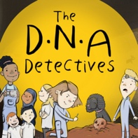
Podcast 4 DNA: Catching criminals

True or False
Here are the questions and answers from Podcast 4 DNA: Catching criminals.

 | Question | Answer
1. | Identical twins inherit different DNA from their parents. | FALSE  The DNA identical twins inherit from their parents is the same.
2. | You can transfer your DNA by just touching a surface. | TRUE  In forensic science this is known as Locard’s Principle ‘Every contact leaves a trace’. It is named after Dr Edward Locard (1877 – 1966) who was a pioneer in forensic science. It is the idea that a person who commits a crime will bring something to the crime scene and will leave with something from it.
3. | The database which holds DNA profiles collected from crime scenes or DNA from people who have been arrested for a crime is called the Grand National DNA Database. | FALSE  It is called the National DNA Database.

To find out more about The DNA Detectives: The Stone Age Mystery book and to order copies click here
https://insightandperspective.co.uk/primary-science-the-dna-detectives

