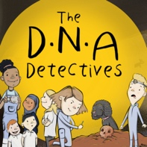
Podcast 3 DNA:

True or False
Here are the questions and answers from Podcast 3 DNA: Defeating Covid-19
 | Question | Answer
1. | The genome for the Coronavirus is made of DNA. | FALSE  It is made of RNA. As Frank said DNA has two strands and looks like a spiral staircase. RNA has only one strand.
2. | If you imagine the RNA in the Coronavirus is like an instruction manual, the variants we hear about are like typos in the instruction manual. | TRUE
3. | If you get vaccinated with the Astra Zeneca vaccine which is made from DNA, all the DNA (the genome) from the Corona virus gets into your cells. | FALSE  It is only a very small fragment of the DNA from the Coronavirus that gets into your cells. This is enough to trigger an immune response in your body which should then spring into action and protect you if you come in contact with the real Covid-19 virus. This reaction from your body stops you getting ill with Covid.  If all the DNA from the virus was used in the vaccine it would make you very ill with Covid-19.  Vaccines can be made using DNA or RNA. The Pfizer vaccine is made from RNA.

To find out more about The DNA Detectives: The Stone Age Mystery book click here
https://insightandperspective.co.uk/primary-science-the-dna-detectives

