Podcast 2 DNA: Unlocking the past

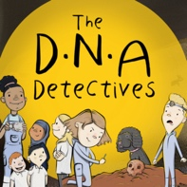

True or False
Here are the questions and answers from Podcast 2 DNA: Unlocking the past.

 | Question | Answer
1. | Cheddar Man’s bones are 1000 years old. | FALSE  Cheddar Man’s bones are approximately 10,000 years old.
2. | Selina got DNA from Cheddar Man’s petrous bone which is in his foot. | FALSE  The petrous bone is in your ear canal. You can click on the weblinks to find out more about the petrous bone and how scientists get DNA from it.
3. | Cheddar Man had straight hair. | FALSE  According to his DNA, Cheddar Man’s hair was curly. You can click on the weblinks to find out more about what he looked like.

To find out more about The DNA Detectives: The Stone Age Mystery book click here
https://insightandperspective.co.uk/primary-science-the-dna-detectives

