Podcast 1 What is DNA?

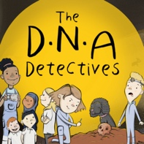

True or False

Here are the questions and answers from Podcast 1 What is DNA?

 | Question | Answer
1. | DNA provides the instructions to make a human and all living things. | TRUE
2. | The human genome (all of the instructions in the DNA) is 100 letters long. | FALSE  The human genome is 3.1 billion letters long.
3. | The letters which make up DNA are A, C, G and T. | TRUE  The letters stand for Adenine, Cytosine, Guanine, and Thyamine.

