Podcast 1 What is DNA?

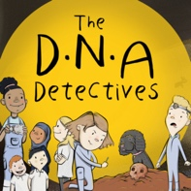

Find out more about DNA

Why not click on some of the links below to find out more about the subjects we discussed in Podcast 1 – What is DNA?
- Watch this video clip to find out what DNA is. http://learn.genetics.utah.edu/content/basics/dna

- Watch this fantastic video to find out What does DNA do?
https://www.yourgenome.org/video/what-does-dna-do

- Watch this video to find out what DNA sequencing looks like in the lab. http://www.yourgenome.org/video/life-in-the-lab-working-in-a-dna-sequencing-pipeline

- Watch this video to find out more about the Wellcome Genome Campus where Fran Gale works.
http://www.youtube.com/watch?v=5Kb7DAOiIKE

- Find out more about the Human Genome Project
http://www.yourgenome.org/stories/what-was-the-human-genome-project-for

- Watch this video to see how the human genome was sequenced (how they found out the order of the letters A, C, G, and T).
http://www.yourgenome.org/video/how-the-human-genome-was-sequenced

- Listen to the stories of the scientists who worked on the Human Genome Project
http://www.yourgenome.org/video/the-human-genome-project-personal-stories

- Find out more about the exciting new Tree of Life Project being carried out at the Sanger Institute.
http://www.youtube.com/watch?v=aK1Ek39z4sA

