Podcast 1 What is DNA?

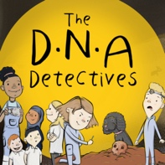

Fun Activities to try
Why not try some of these fun activities to learn more about DNA. You can also try our DNA Sequencing activity.

- Have a go at making an origami DNA Helix.
https://www.yourgenome.org/activities/origami-dna

- Have a go a making a DNA Helix out of sweets!
https://www.yourgenome.org/activities/yummy-gummy-dna

- Why don’t you try extracting some DNA at home? Read the blog and then watch the video clip below to find out how.
http://www.home.oxfordowl.co.uk/blog/science-at-home-how-to-extract-dna-from-a-banana/
http://www.youtube.com/watch?v=xA_YyeAFojo

- Have a go at extracting some DNA in this virtual laboratory with real pipettes and centrifuges.
https://learn.genetics.utah.edu/content/labs/extraction/

- In Podcast 1 Fran talks about the machine which ‘sequences’ the DNA to find out the order of letters, A, C, G, and T. Try this fun game and see if you can beat the machine to work out the sequence.
https://www.yourgenome.org/interactives/you-vs-machine

- Why not make some DNA sequence bracelets?
http://www.yourgenome.org/activities/sequence-bracelets

